Information Technology
Project Management
A Complete Textbook
Based on Information Technology Project Management, Seventh Edition

Table of Contents
Chapter 1: Introduction to IT Project Management 1
1.1 Overview 1
1.2 The Scale of Global Project Spending 1
1.3 Why IT Projects Have a Poor Track Record 1
1.4 Real-World Example 1
Chapter 2: Definition and Attributes of a Project 1
2.1 What Is a Project? 1
2.2 Key Attributes of a Project 1
2.3 Real-World Example 1
Chapter 3: Definition of Project Management 1
3.1 What Is Project Management? 1
3.2 Project Management Knowledge Areas 1
3.3 Real-World Example 1
Chapter 4: The Triple Constraint 1
4.1 What Is the Triple Constraint? 1
4.2 Satisfying the Project Sponsor 1
4.3 Real-World Example 1
Chapter 5: Project Stakeholders 1
5.1 Who Are Project Stakeholders? 1
5.2 Types of Stakeholders 1
5.3 Real-World Example 1
Chapter 6: Advantages and Success Factors 1
6.1 Advantages of Formal Project Management 1
6.2 How Project Success Is Defined 1
6.3 Improved Project Performance Over Time 1
6.4 Top Factors That Help Projects Succeed 1
6.5 Real-World Example 1
Chapter 7: Tools and Techniques 1
7.1 What Are Project Management Tools and Techniques? 1
7.2 Gantt Charts 1
7.3 Network Diagrams 1
7.4 Project Management Software 1
7.5 Real-World Example 1
Chapter 8: Programs and Portfolios 1
8.1 The Difference Between Projects, Programs, and Portfolios 1
8.2 What Is a Program? 1
8.3 Programs Versus Projects 1
8.4 What Is Project Portfolio Management? 1
8.5 Portfolio Categories 1
8.6 Portfolio Management Software 1
8.7 Real-World Example 1
Chapter 9: Project Management Offices (PMOs) 1
9.1 What Is a Project Management Office? 1
9.2 Adoption of PMOs 1
9.3 Why PMOs Fail 1
9.4 Real-World Example 1
Chapter 10: The Project Manager Role and Skills 1
10.1 The Role of the Project Manager 1
10.2 Suggested Skills for Project Managers 1
10.3 Leadership Versus Management 1
10.4 Top Ten Competencies for Project Managers 1
10.5 Different Skills for Different Situations 1
10.6 Real-World Example 1
Chapter 11: The Profession and Careers 1
11.1 The Growth of the Project Management Profession 1
11.2 IT as a Career Path 1
11.3 Global Issues Affecting the Profession 1
11.4 Real-World Example 1
Chapter 12: Certification and Ethics 1
12.1 The Project Management Institute (PMI) 1
12.2 Project Management Professional (PMP) Certification 1
12.3 Certified Associate in Project Management (CAPM) 1
12.4 CompTIA Project+ Certification 1
12.5 Ethics in Project Management 1
12.6 Real-World Example 1
12.7 Conclusion 1

Chapter 1: Introduction to IT Project Management

1.1 Overview
Information Technology (IT) Project Management is the practice of organizing, planning, and controlling technology-based projects. As organizations invest more in technology, the need to manage these investments well has grown. This chapter introduces why IT project management matters and what the global landscape looks like.

1.2 The Scale of Global Project Spending
The world spends nearly $10 trillion of its total $40.7 trillion gross product on projects of all kinds. This means that projects are not small or rare activities. They are a major part of how the global economy operates.
More than 16 million people consider project management to be their profession. The information and communications technology (ICT) market grew by 6 percent to reach almost $3 trillion as of 2010. This rapid growth means that demand for skilled IT project managers continues to rise.

1.3 Why IT Projects Have a Poor Track Record
Despite the large amount of money invested in IT projects, many of these projects fail. They go over budget, take longer than planned, or do not deliver the results that were expected. Industry reports, such as the Standish Group's CHAOS Report, have documented this poor track record for many years.
This situation makes it essential to study IT project management. By learning the right methods, tools, and practices, professionals can greatly improve the chances of project success.
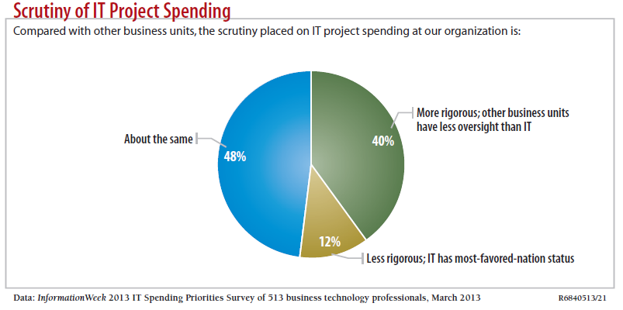

1.4 Real-World Example
Consider a large bank that decides to upgrade its core banking software. The bank spends $50 million on the project. Without a formal project management approach, the team has no clear plan, no risk management strategy, and no way to track progress. Two years later, the project is still not complete. Costs have doubled. Customers are frustrated because new features are delayed.
This is a common example of what happens when IT projects are not managed properly. A structured project management approach would have helped the bank set clear goals, monitor progress, and respond to problems early.

Chapter 2: Definition and Attributes of a Project

2.1 What Is a Project?
A project is defined as a temporary endeavor undertaken to create a unique product, service, or result. This definition comes from the Project Management Body of Knowledge (PMBOK Guide, Fifth Edition, 2012).
Two key words in this definition are important to understand: temporary and unique. Temporary means that every project has a defined start and end date. It does not go on forever. Unique means that the result of the project is different from anything else that the organization has produced before.
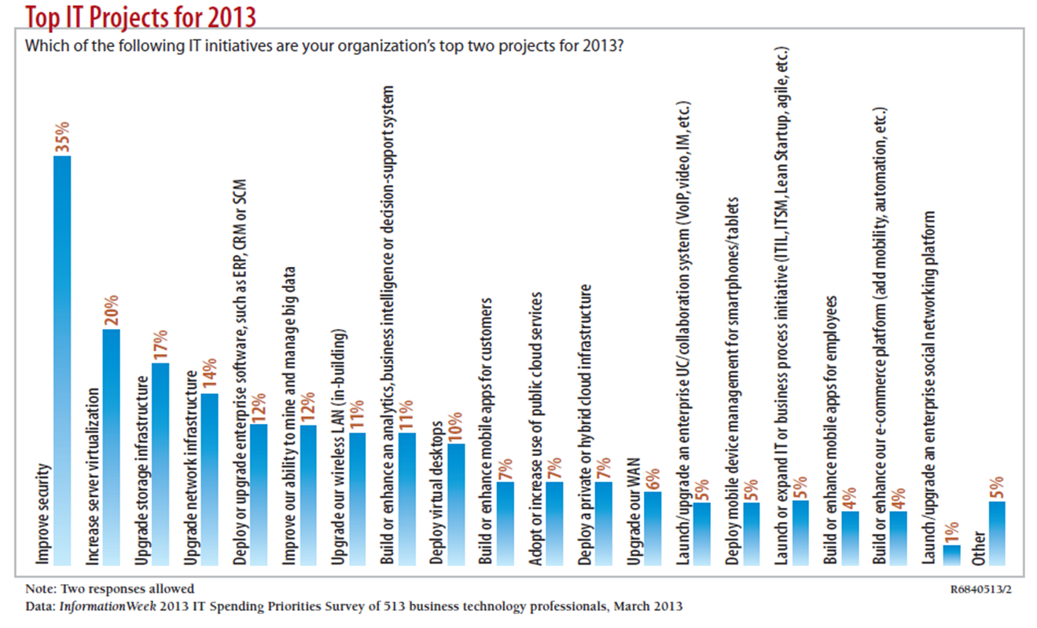

2.2 Key Attributes of a Project
Projects share several important characteristics. Understanding these attributes helps a manager identify what is and what is not a project.
- A project has a unique purpose. Each project aims to create something that has not existed before in the same form.
- A project is temporary. It has a clear beginning and a clear end.
- A project is developed using progressive elaboration. This means the plan becomes more detailed as the project moves forward and more information becomes available.
- A project requires resources, often from various areas. These resources include people, money, equipment, and materials.
- A project should have a primary customer or sponsor. The project sponsor provides direction and funding for the project.
- A project involves uncertainty. Because a project is unique, there are always unknowns that must be managed.

2.3 Real-World Example
Consider the development of a new mobile banking application. This is a project because it has a clear start date (when the team is formed), a clear end date (when the app is launched), a unique purpose (no identical app exists), and it requires a team of developers, designers, and testers. The project sponsor is the bank's Chief Technology Officer, who provides the budget and approves the final product.
Once the app is live and the bank's IT team begins maintaining it, that work is no longer a project. It becomes an ongoing operation.

Chapter 3: Definition of Project Management

3.1 What Is Project Management?
Project management is defined as the application of knowledge, skills, tools, and techniques to project activities in order to meet project requirements. This definition also comes from the PMBOK Guide.
In simple terms, project management means using the right knowledge and the right tools to plan, execute, and control a project so that it meets its goals on time and within budget.
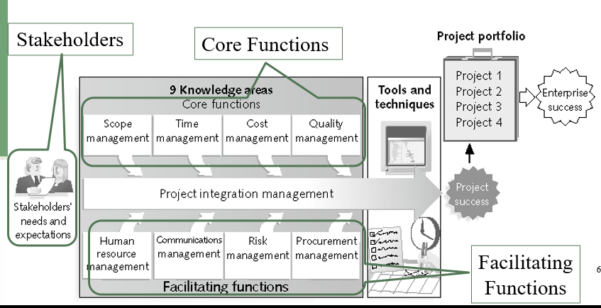

3.2 Project Management Knowledge Areas
The PMBOK Guide organizes project management into ten knowledge areas. These areas describe the key competencies that project managers must develop. They are grouped into three categories:
Core Functions
The core functions address the most essential aspects of managing a project:
- Scope Management: Defining what work is included in the project.
- Time Management: Planning the schedule and ensuring the project finishes on time.
- Cost Management: Estimating and controlling the budget.
- Quality Management: Ensuring the project's output meets the required standards.
Facilitating Functions
The facilitating functions support the core work of the project:
- Human Resource Management: Managing the people on the project team.
- Communications Management: Ensuring that information flows correctly among all parties.
- Risk Management: Identifying and responding to potential problems.
- Procurement Management: Managing contracts and purchases from outside the project.
- Stakeholder Management: Engaging the people who are affected by the project.
Integration Function
Integration Management ties all the other knowledge areas together. It ensures that the different parts of the project work in harmony.

3.3 Real-World Example
A hospital wants to implement a new electronic health records (EHR) system. The project manager must apply knowledge from all areas: defining the scope of which departments will use the system, creating a time schedule for installation, estimating costs for software licenses, managing the IT staff and nurses involved in testing, communicating updates to hospital administration, and identifying risks such as data security threats. This multi-area coordination is the essence of project management.

Chapter 4: The Triple Constraint

4.1 What Is the Triple Constraint?
Every project must balance three competing demands: scope, time, and cost. This balancing act is known as the Triple Constraint of project management, and it is one of the most fundamental concepts in the field.
- Scope refers to the work that must be completed and the features that the final product must include.
- Time refers to the schedule, or how long the project will take to complete.
- Cost refers to the approved budget for the project.
These three elements are interconnected. A change in one will usually affect the others. For example, if the project scope is increased (more features are added), either more time or more money, or both, will be needed.
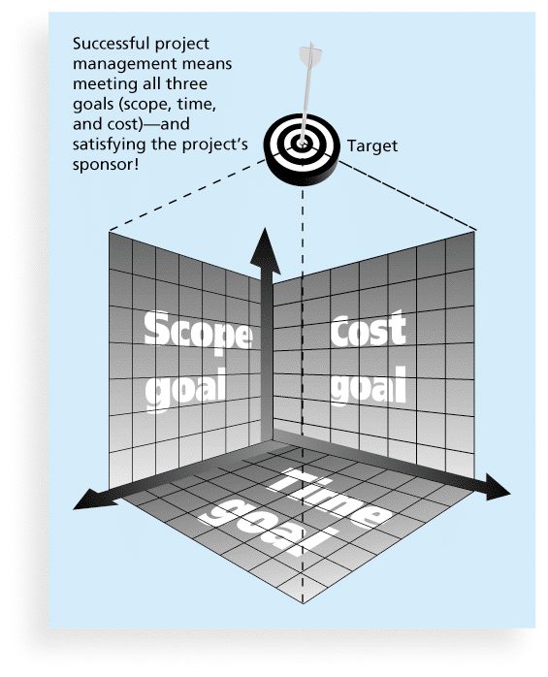

4.2 Satisfying the Project Sponsor
The goal of managing the Triple Constraint is to satisfy the project sponsor. The sponsor is the person or group who provides the funding and has the highest level of authority over the project. The project manager must keep the sponsor informed about any changes to scope, time, or cost and must obtain the sponsor's approval before making significant adjustments.

4.3 Real-World Example
A government agency commissions the development of a new tax-filing website. The original plan calls for a six-month timeline and a budget of $2 million. Midway through the project, the agency asks for the addition of a new feature: a real-time tax calculator. This change expands the scope. The project manager must now inform the sponsor that either the timeline must be extended to eight months, the budget must be increased to $2.4 million, or some other features must be removed to keep the original schedule and budget. The sponsor then decides which trade-off is acceptable.

Chapter 5: Project Stakeholders

5.1 Who Are Project Stakeholders?
Stakeholders are the people who are involved in or affected by project activities. They can be directly or indirectly connected to the project. Identifying and managing stakeholders is a critical responsibility of the project manager.

5.2 Types of Stakeholders
Project stakeholders typically include:
- The Project Sponsor: The individual or group that provides financial resources and executive support.
- The Project Manager: The person responsible for managing the project on a daily basis.
- The Project Team: The individuals who perform the work of the project.
- Customers or End Users: The people who will use the product or service created by the project.
- Management: Senior leaders within the organization who have an interest in the project's outcome.
- Suppliers and Vendors: External parties that provide goods or services to the project.
- Regulatory Bodies: Government agencies or industry groups that establish rules the project must follow.

5.3 Real-World Example
Consider a city government project to build a new public transportation app. The stakeholders include: the city mayor (sponsor), the IT project manager, the development team, commuters (end users), the city's transportation department (customer), app store providers (vendors), and data privacy regulators. Each group has different interests and needs. The project manager must communicate with all of them and address their concerns throughout the project.

Chapter 6: Advantages and Success Factors

6.1 Advantages of Formal Project Management
Using a formal project management approach brings many benefits to an organization. These benefits apply to both the project itself and to the broader organization.
- Better control of financial, physical, and human resources.
- Improved customer relations.
- Shorter development times.
- Lower costs.
- Higher quality and increased reliability.
- Higher profit margins.
- Improved productivity.
- Better internal coordination.
- Higher worker morale.

6.2 How Project Success Is Defined
Success in project management can be measured in more than one way. There are three common frameworks for defining success:
- The Triple Constraint: The project was completed on time, within budget, and with all required features.
- Customer and Sponsor Satisfaction: The people who funded or requested the project feel that the result met their expectations.
- Achieving the Main Objective: The product or service created by the project fulfills the main business goal it was intended to achieve.

6.3 Improved Project Performance Over Time
Industry data shows that project performance has improved over the years. More projects are now completed on time and within budget than in previous decades. This improvement is linked to the growth in formal project management training and certification, better tools, and improved methodologies.
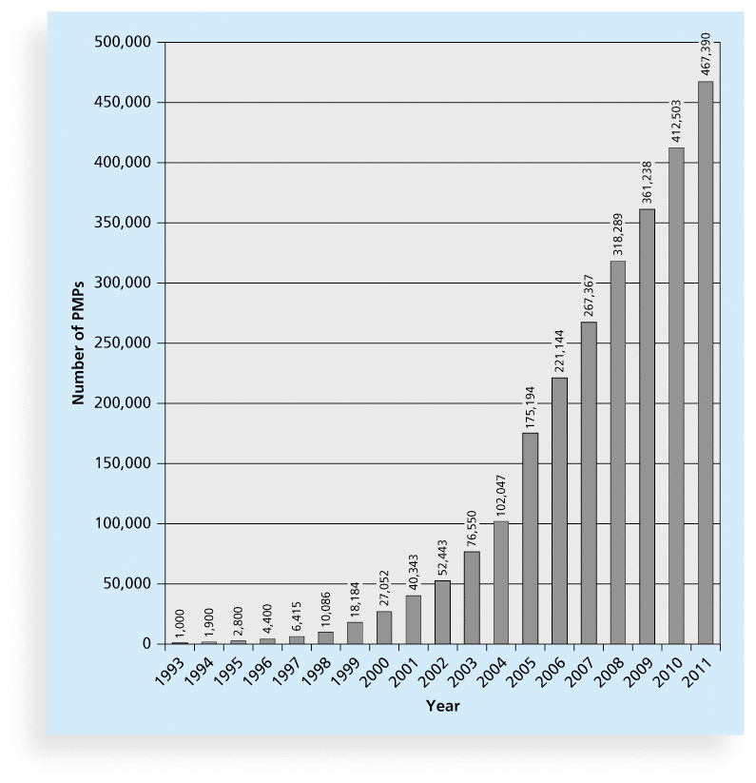

6.4 Top Factors That Help Projects Succeed
The Standish Group, a research firm that has studied thousands of IT projects, identified the top ten factors that help projects succeed. These are listed in order of importance:
- User involvement
- Executive support
- Clear business objectives
- Emotional maturity
- Optimizing scope
- Agile process
- Project management expertise
- Skilled resources
- Execution
- Tools and infrastructure
Among these, user involvement and executive support consistently rank as the most important. When the people who will use the final product are actively engaged, and when senior leaders visibly support the project, the chance of success rises significantly.

6.5 Real-World Example
An insurance company sets out to build a new claims processing system. The IT team works in isolation, with no input from the claims adjusters who will use the system daily. Senior management shows little interest in the project. When the system is launched, the adjusters find it confusing and inefficient. The project is considered a failure, even though it was delivered on time.
Had the project followed the top success factors, the claims adjusters would have been involved from the beginning to share their needs. Executive support would have ensured resources were available and obstacles were removed quickly.

Chapter 7: Tools and Techniques

7.1 What Are Project Management Tools and Techniques?
Project management tools and techniques are structured methods that help project managers and their teams plan, track, and communicate about a project. These tools make complex information easier to understand and manage.

7.2 Gantt Charts
A Gantt chart is a type of bar chart that shows the schedule of a project. It lists all the project tasks on the left side and displays a horizontal bar for each task on a timeline. The length of the bar shows how long the task is expected to take.
Gantt charts are widely used because they are easy to read. Anyone can look at a Gantt chart and quickly understand which tasks are happening when and whether the project is on schedule.
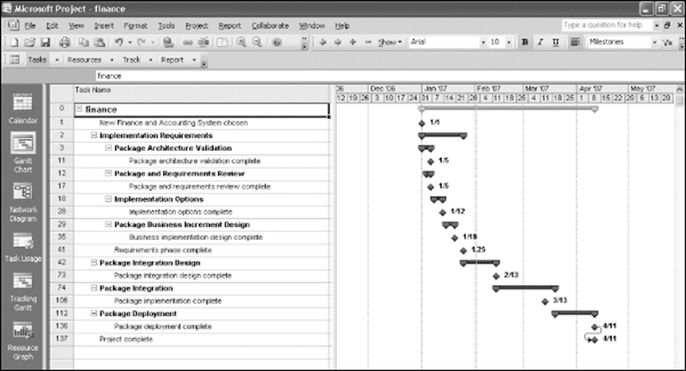

7.3 Network Diagrams
A network diagram is a visual representation of the sequence of project activities and the dependencies between them. Unlike a Gantt chart, a network diagram shows the logical order in which tasks must be completed.
Network diagrams are used to calculate the Critical Path of a project. The Critical Path is the longest sequence of dependent tasks. Any delay on the Critical Path will delay the entire project.
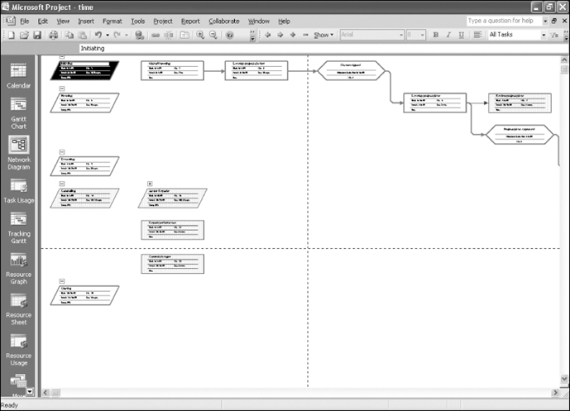

7.4 Project Management Software
There are hundreds of software products designed to assist with project management. These products are grouped into three main categories:
- Low-end tools: Simple, inexpensive tools designed for individuals or small teams. These often include basic task lists and calendar features.
- Midrange tools: More powerful tools suitable for medium-sized projects. These typically support Gantt charts, resource tracking, and team collaboration.
- High-end tools: Enterprise-grade software designed for large, complex projects and portfolios. These tools offer advanced features such as portfolio management, detailed resource planning, and integration with financial systems.
Some examples of project management software include Basecamp, Clarizen, dotProject, OneDesk, and PlanBox. Open source options such as Collabtive are also available for teams with limited budgets.

7.5 Real-World Example
A software development company uses Microsoft Project to manage a two-year system migration project. The project manager creates a Gantt chart showing all phases, from requirements gathering to testing and deployment. The network diagram reveals that the database migration is on the critical path, meaning any delay there will push back the entire release. The project manager pays special attention to this task and assigns extra resources to keep it on schedule.

Chapter 8: Programs and Portfolios

8.1 The Difference Between Projects, Programs, and Portfolios
Project management does not only apply to individual projects. Organizations often manage many projects at the same time. To do this effectively, they use two higher-level concepts: programs and portfolios.

8.2 What Is a Program?
A program is a group of related projects managed in a coordinated way in order to obtain benefits and control that would not be possible if the projects were managed separately. This definition comes from the PMBOK Guide.
A program manager provides leadership and direction to the project managers who lead the individual projects within the program. The program manager focuses on how the projects relate to and support each other.

8.3 Programs Versus Projects
A common question is whether there is a real difference between a very large project and a program. The key distinction is coordination. Projects in a program share resources, have interdependencies, and are managed together to achieve a strategic goal. Managing them as a program allows the organization to recognize these relationships and manage them intentionally.
A program manager typically needs a broader set of skills than a project manager. While a project manager focuses on a single deliverable, a program manager must see the larger strategic picture.

8.4 What Is Project Portfolio Management?
Project portfolio management means that an organization groups and manages its projects and programs as a portfolio of investments. The goal is to ensure that all projects contribute to the organization's overall strategic goals.
A portfolio is not simply a list of all active projects. It is a carefully selected set of projects that together create the most value for the organization. Portfolio management involves deciding which projects to start, which to continue, and which to stop.
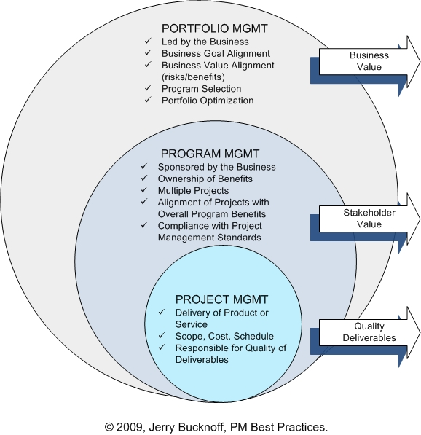

8.5 Portfolio Categories
Organizations may classify their portfolio investments into categories such as:
- Derivative projects: Small improvements to existing products or processes.
- Platform projects: Fundamental redesigns of existing products.
- Breakthrough projects: New-to-the-world innovations that create entirely new categories.
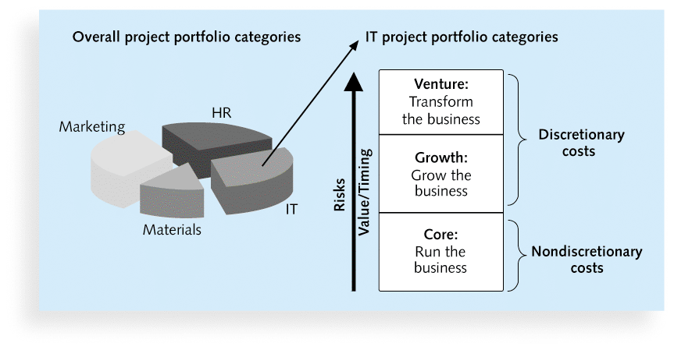

8.6 Portfolio Management Software
Organizations use specialized software to manage their portfolios. These tools allow managers to see all active projects on a single screen, compare them by cost, benefit, risk, and strategic alignment, and make informed decisions about which projects to prioritize.
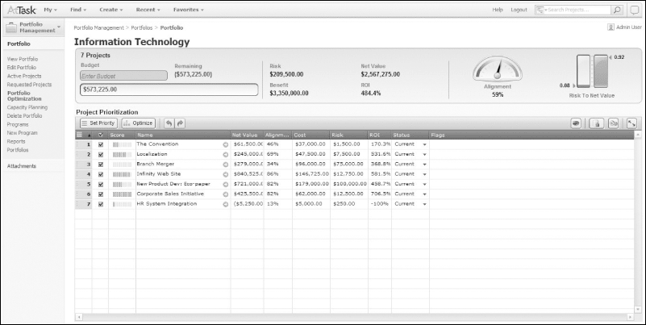

8.7 Real-World Example
A large telecommunications company has dozens of IT projects running simultaneously. Some projects focus on improving network infrastructure, others on developing new customer-facing applications, and others on reducing operational costs. By organizing these projects into a portfolio, the company's leadership can see how each project contributes to its five-year strategic plan. Projects that do not contribute to any strategic goal are cancelled, and the freed resources are redirected to higher-priority work.

Chapter 9: Project Management Offices (PMOs)

9.1 What Is a Project Management Office?
A Project Management Office, commonly called a PMO, is an organizational group that is responsible for coordinating the project management function throughout an organization. It serves as a central hub for project management standards, training, tools, and processes.
The PMO helps ensure that all projects in an organization follow consistent methods. It may provide templates, guidelines, training for project managers, and oversight of active projects.

9.2 Adoption of PMOs
PMOs have become increasingly common in large organizations. Many companies have established PMOs because they recognize the need for greater consistency and control across their project portfolios. However, the rate of adoption varies across industries and regions.
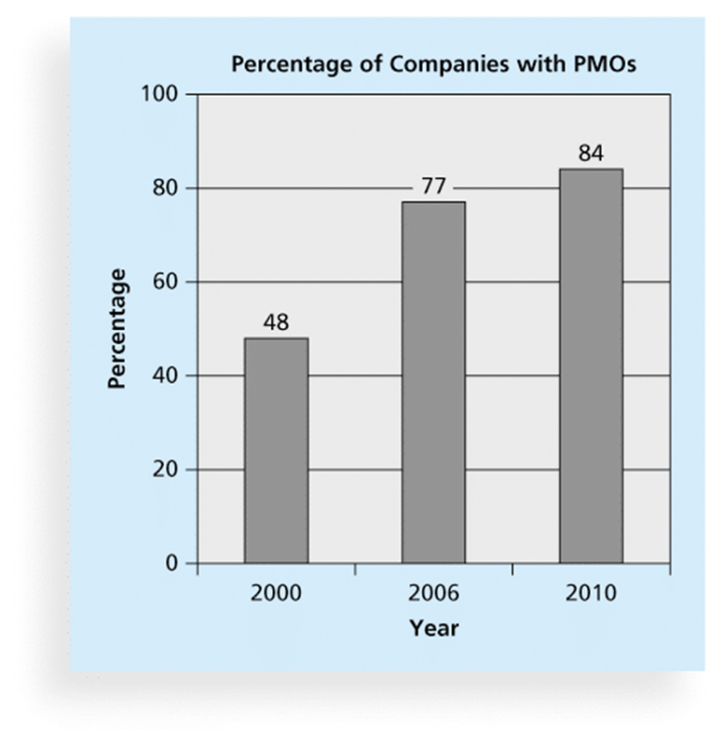

9.3 Why PMOs Fail
Despite their potential benefits, PMOs sometimes fail. Research and industry discussions have identified several common reasons:
- Lack of executive support: If senior leadership does not champion the PMO, it loses authority and influence.
- Poor communication: The PMO may not effectively communicate its value to the rest of the organization.
- Too much bureaucracy: A PMO that creates excessive paperwork and approvals may frustrate project teams.
- Failure to adapt: A PMO that does not evolve its practices to meet changing business needs becomes irrelevant.
- Lack of qualified staff: Running a PMO requires experienced project management professionals.

9.4 Real-World Example
A financial services firm establishes a PMO to improve its track record on IT projects. In the first year, the PMO creates standard templates, trains project managers, and reports on project health to the executive team. Over time, senior management stops attending PMO review meetings and reduces the PMO's budget. Without executive attention, project managers begin ignoring PMO guidelines, and the PMO eventually closes. The firm later recognizes that sustained leadership commitment was the missing ingredient.

Chapter 10: The Project Manager Role and Skills

10.1 The Role of the Project Manager
The project manager is the person responsible for leading the project team and ensuring that the project meets its goals. Job descriptions for project managers vary by organization and industry, but most include responsibilities such as:
- Planning the project scope, schedule, and budget.
- Scheduling and assigning tasks to team members.
- Coordinating communication among stakeholders.
- Monitoring project progress and making adjustments when necessary.
- Managing risks and resolving issues.
- Working with people at all levels of the organization to achieve project goals.
Research shows that 97 percent of successful projects were led by experienced project managers. This statistic highlights just how important the project manager's role is to achieving a good outcome.

10.2 Suggested Skills for Project Managers
The PMBOK Guide identifies several categories of knowledge and skill that project managers should develop:
- The Project Management Body of Knowledge: Mastery of the standard frameworks, tools, and techniques of the profession.
- Application area knowledge, standards, and regulations: Understanding the specific industry in which the project takes place.
- Project environment knowledge: Awareness of the political, social, and organizational factors that affect the project.
- General management knowledge and skills: Basic business skills such as finance, planning, and organizational behavior.
- Soft skills, or human relations skills: The ability to communicate, motivate, and work effectively with people.

10.3 Leadership Versus Management
Project managers must often perform both leadership and management functions, and it is important to understand the difference:
- A leader focuses on long-term goals and the big picture. Leaders inspire and motivate people to move toward a vision.
- A manager deals with the day-to-day details of meeting specific goals. Managers plan, organize, and control.
Effective project managers lead by example. They demonstrate the behaviors and standards they expect from their teams. In practice, project managers frequently take on both roles at the same time, adapting their approach to the situation.

10.4 Top Ten Competencies for Project Managers
The following ten skills and competencies are consistently ranked as the most important for effective project managers:
- People skills: The ability to work effectively with diverse individuals and groups.
- Leadership: Guiding and inspiring the team toward the project goals.
- Listening: Actively hearing and understanding what team members and stakeholders are saying.
- Integrity, ethical behavior, and consistency: Acting with honesty and fairness in all situations.
- Strong at building trust: Creating an environment where team members feel safe and respected.
- Verbal communication: Expressing ideas clearly and concisely in speech.
- Strong at building teams: Bringing together individuals to function as a productive unit.
- Conflict resolution and conflict management: Addressing disagreements and finding constructive solutions.
- Critical thinking and problem solving: Analyzing situations and finding effective responses.
- Understands and balances priorities: Knowing what matters most and managing competing demands.

10.5 Different Skills for Different Situations
The skills a project manager must emphasize will vary depending on the nature of the project:
- Large projects: Require strong organizational and delegation skills, as well as the ability to manage many people and workstreams simultaneously.
- High uncertainty projects: Require strong risk management and adaptive thinking, so the manager can respond quickly to unexpected changes.
- Very novel projects: Require creativity, flexibility, and the willingness to explore new approaches without a clear roadmap.

10.6 Real-World Example
A project manager at a logistics company is assigned to lead the integration of two different warehouse management systems following a corporate merger. The project is large, with over 50 team members across three countries. The manager must apply strong people skills to build trust with a team that does not know each other, use verbal and written communication to bridge language and cultural differences, and apply critical thinking to resolve the technical conflicts between the two legacy systems.

Chapter 11: The Profession and Careers

11.1 The Growth of the Project Management Profession
Project management has grown into a recognized and respected profession over the past few decades. The demand for project managers is increasing worldwide, driven by the complexity of modern business operations and the rapid pace of technological change.
Professional organizations, particularly the Project Management Institute (PMI), have played a major role in shaping the profession. PMI develops standards, provides certification, and represents the interests of project management professionals globally.

11.2 IT as a Career Path
In a 2012 survey, IT executives listed the nine hottest skills they planned to hire for in the following year. Project management ranked second, just behind programming and application development. This ranking confirms that project management is a highly valued and sought-after skill in the technology industry.
The survey results showed the following ranking of in-demand IT skills:
- Programming and application development: 60% of respondents
- Project management: 44% of respondents
- Help desk and technical support: 35% of respondents
- Networking: 35% of respondents
- Business intelligence: 23% of respondents
- Data center: 18% of respondents
- Web 2.0: 18% of respondents
- Security: 17% of respondents
- Telecommunications: 9% of respondents

11.3 Global Issues Affecting the Profession
Several global trends are changing how organizations approach project management:
- Talent development: Finding and developing skilled project and program managers is a top concern for organizations worldwide.
- Portfolio management in tight economies: When budgets are limited, good portfolio management becomes even more important to ensure resources are directed to the highest-value projects.
- Core competencies: Organizations are recognizing that basic project management skills are no longer optional. They are essential competencies for all employees involved in project work.
- Agile approaches: Many organizations are moving toward more flexible, iterative project management methods that allow them to respond faster to changing business needs.
- Benefits realization: Organizations are increasingly measuring projects not just by whether they were delivered on time and within budget, but by whether they actually delivered the expected business benefits.

11.4 Real-World Example
A graduate student studying computer science decides to pursue a career in IT project management. She completes her degree, then works as a junior project coordinator at a software firm. Over five years, she gains experience managing progressively larger projects. She studies for the PMP certification and passes the exam. Her salary increases significantly, and she is offered a senior project manager role at a multinational technology company. Her story reflects the career growth potential that the project management profession offers in the IT industry.

Chapter 12: Certification and Ethics

12.1 The Project Management Institute (PMI)
The Project Management Institute, known as PMI, is the leading international professional society for project managers. As of 2012, PMI had approximately 380,000 members in countries around the world. PMI develops the PMBOK Guide, sets professional standards, and offers internationally recognized certifications.

12.2 Project Management Professional (PMP) Certification
The Project Management Professional, or PMP, is the most widely recognized project management certification in the world. To earn the PMP credential, a candidate must:
- Have documented a sufficient amount of project management experience (the number of hours required depends on the candidate's level of education).
- Agree to follow PMI's Code of Ethics and Professional Conduct.
- Pass the PMP certification examination.
The PMP certification demonstrates that a project manager has the knowledge, skills, and experience to lead and direct projects successfully.

12.3 Certified Associate in Project Management (CAPM)
The Certified Associate in Project Management, or CAPM, is an entry-level certification from PMI. It is designed for individuals who are new to project management and do not yet have the experience required for the PMP exam. The CAPM certification is a good starting point for students and early-career professionals who want to demonstrate their commitment to the field.

12.4 CompTIA Project+ Certification
CompTIA, another professional organization, offers the Project+ certification. This certification has fewer requirements than the PMP and is therefore more accessible to beginners. However, it is not as widely recognized in the industry as the PMP. It may be a suitable option for those seeking a basic, foundational credential in project management.

12.5 Ethics in Project Management
Ethics refers to a set of principles that guide decision-making based on personal values of what is right and wrong. Project managers regularly face situations where ethical judgment is required. These situations may involve conflicts of interest, pressure to misrepresent project status, or decisions that affect the well-being of stakeholders.
To earn PMP certification, applicants must agree to abide by PMI's Code of Ethics and Professional Conduct. This code outlines the responsibilities that certified project managers owe to the profession and to the public. Several questions on the PMP examination are also related to professional responsibility and ethics.
The four core values in PMI's Code of Ethics are:
- Responsibility: Taking ownership of decisions and their consequences.
- Respect: Treating all stakeholders with dignity and consideration.
- Fairness: Making decisions based on objective criteria without favoritism or self-interest.
- Honesty: Communicating truthfully in all project matters.

12.6 Real-World Example
A project manager at a construction technology firm notices that a key software module is not working correctly. Reporting the problem honestly will delay the project by three weeks and upset the project sponsor. Some colleagues suggest hiding the issue until after the next progress review. The project manager chooses to report the problem immediately and presents a revised plan to address it. This decision reflects the PMI Code of Ethics values of honesty and responsibility. Although the news is difficult, stakeholders appreciate the transparency and work collaboratively to find a solution.

12.7 Conclusion
This textbook has introduced the fundamental concepts of Information Technology Project Management. From understanding what a project is, to mastering the triple constraint, to learning about the role of the project manager and the importance of ethics, these chapters provide a solid foundation for anyone entering or advancing in the field.
The project management profession is growing rapidly, and the demand for skilled, certified professionals is high. By applying the concepts covered in this book, and by pursuing recognized certifications such as the PMP, individuals can build rewarding careers and help their organizations succeed in an increasingly complex technological world.

